The organization
TOFI Together for inclusion International is a International humanitarian organization founded in 1993

The General Secretariat/ President and the Executive Management Team
The executive management team of the Together for Inclusion International and the Secretary General are responsible for running TOFI s daily affairs. The Secretary General / President is appointed by the Board of Directors.

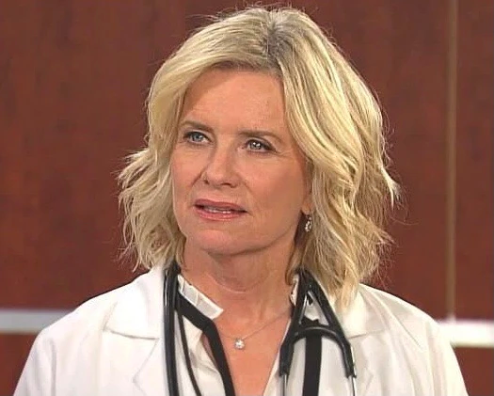

Prior to joining Together for Inclusion International, Caroline Brady built a distinguished career in international diplomacy, development cooperation, and humanitarian affairs, serving in a number of senior leadership positions.
Among her most significant roles, she served as State Secretary for Development Policy, where she directed the national development agency and oversaw international development and humanitarian strategies, programs, and partnerships. She also served as Under-Secretary of State for Global Politics and Security, leading foreign policy departments responsible for relations with Africa, Asia, Latin America, and the Middle East. Additional senior appointments included Ambassador for Fragile States and Under-Secretary of State for Consular Affairs.
Throughout her career, Caroline Brady held senior diplomatic assignments in Latin America and the Middle East, including ambassadorial postings, where she strengthened bilateral relations and advanced international development objectives.
She began her professional career with the United Nations High Commissioner for Human Rights, working for five years in Equatorial Guinea, Central Africa, supporting governance reforms and local development initiatives.
Caroline Brady holds a Master of Science in International Business Administration and Modern Languages from the London School of Tropical Medicine. She is fluent in French, English, and Spanish
Director Regional Bureau for East, Horn & Great Lakes
Mr. Ibrahim Sheikh Ali serves as the TOFI Director Regional Bureau for East , Horn & Great Lakes, a position he assumed in January 2024. He is a seasoned humanitarian professional with more than 15 years of experience in humanitarian and protection programming, spanning field operations, regional leadership, and headquarters-level assignments.
Prior to his current role, Mr. Ibrahim served as Deputy Director at the Regional Bureau for Eastern and Southern Africa (RBESA), where he provided strategic leadership, oversight, and coordination of protection and solutions initiatives across multiple country operations. In this capacity, he played a pivotal role in advancing complex cross-border interventions, managing politically sensitive protection environments, and strengthening regional coherence in both emergency and protracted displacement contexts.
Widely respected across the humanitarian sector for his dedication, energy, and collaborative leadership style, Mr. Ibrahim has demonstrated exceptional commitment in some of the most challenging humanitarian settings. His extensive experience includes leading large-scale emergency and displacement responses, particularly in Kenya's Dadaab refugee complex and across the Horn of Africa region. He combines strong strategic vision with practical operational expertise in managing complex humanitarian emergencies.
Throughout his career, Mr. Ibrahim has served in senior leadership positions, including Deputy Representative roles, where he led operations during periods of large-scale conflict, regional instability, and acute humanitarian crises. He has successfully cultivated high-level partnerships with governments, donors, United Nations agencies, non-governmental organizations, and development actors while overseeing diverse and complex operational portfolios.
Mr. Ibrahim has led humanitarian responses in both acute emergencies and protracted displacement situations across Somalia, Kenya, and Ethiopia. His leadership approach consistently integrates strong protection principles with pragmatic, solutions-oriented strategies tailored to complex and politically sensitive environments.
In addition to his work with TOFI, Mr. Ibrahim has held senior positions with several leading international humanitarian organizations, including UNHCR, CARE International, Save the Children UK, and the Danish Refugee Council (DRC). His experience includes serving as a Senior Protection and Emergency Coordinator, where he contributed to policy development, emergency response leadership, and capacity-building initiatives across East Africa and the Middle East.
Mr. Ibrahim holds a Bachelor of Education (B.Ed.) from Kampala International University and a Master's Degree in International Relations and Diplomacy from Kenya Methodist University. He is multilingual and fluent in English, French, Arabic, and Somali, enabling him to engage effectively across diverse cultural and operational contexts.

